Design Document

WLAN Mesh Architecture and Frame Definitions
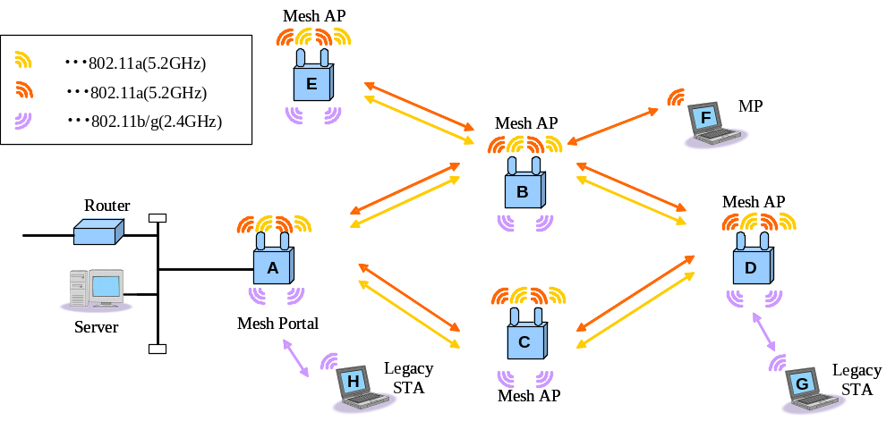
图 1 Proposed WLAN mesh network model.
Architecture.
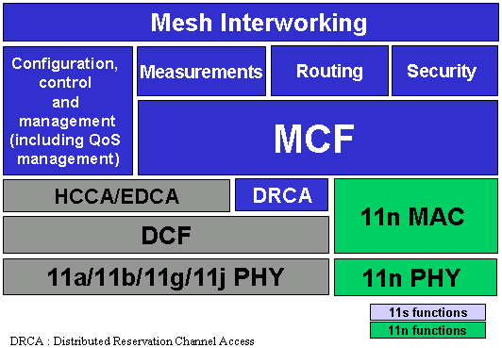
图 2 WiFi Mesh Architecture

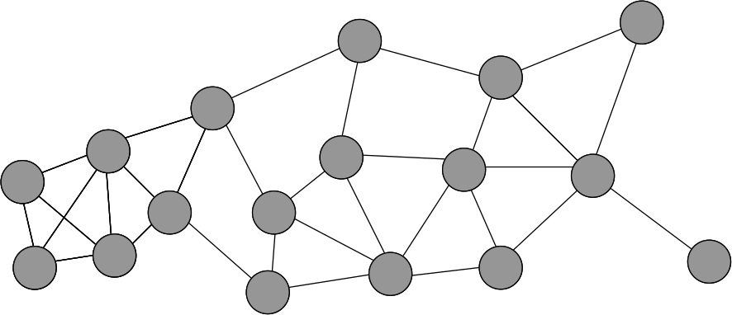
图 3 Mesh Membership – Physical Link
Physical link (in radio range).
Every MP can talk with any other MP as long as they are in range
All MPs are a single big mesh.
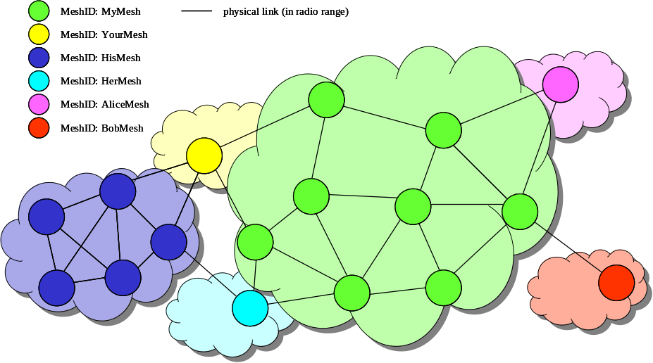
图 4 Mesh Membership – Mesh Profile
MPs know to which mesh they belong (Mesh ID)
Still, every MP can send frames to any other MP as long as they are in range
If two different meshes have the same active path selection protocol and path selection metric, they behave as a single big mesh (paths are found over both meshes)
Want some means to ensure forwarding of frames only to MPs of the same mesh
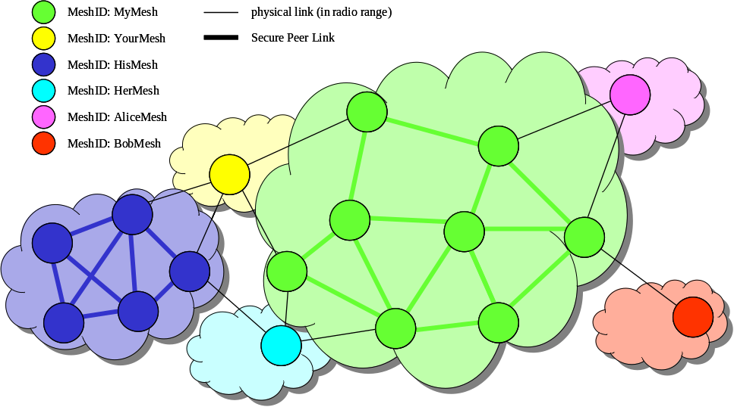
图 5 Mesh Membership – Peer Links and MSA Security Associations
MPs know to which mesh they belong (Mesh ID)
Every MP can send frames to any other MP it has a peer link with security association
Every MP knows which frames to discard, because they are not from a peer MP with security association
If two different meshes have the same active path selection protocol and path selection metric, they behave as two different meshes:
Paths are only found in the same mesh
No frames can be forwarded between MPs of different meshes
Peer link establishment / MSA authentication gives a list of MPs that are allowed to communicate with the local MP

Features

Complete solution addressing all 802.11s Usage Models
Flexible & suitable for Simple / Robust implementations, as well as Sophisticated / High Performance systems

Dynamic routing support
QoS, radio & power-efficiency aware routing with WDS four-addressing extension that supports dynamic auto-configuration of MAC-layer data delivery paths for unicast, multicast & broadcast, as well as integrated BSS & WLAN mesh unicast data delivery, with efficient broadcast/multicast transport

Support for single & multi-radio configurations
Providing an efficient channel usage for regulatory limited domains (e.g. Japan), it leverages at all times on all available RF resources (e.g. channels, radios, etc.)

Flexible and secure
With authentication and key management procedures using 802.11i concepts, it provides secure key distribution and secure exchange of routing information, supporting distributed or centralized models

Seamless routing and security integration
Agnostic to radio types, wireless stations or applications, it provides mesh extensions with multi-hop encryption of unicast/multicast data
Secure neighborhood association performed at Beacon or hello time, and multi-hop encryption hop-by-hop authentication with multicast and tunnel support
Optional Knobs for re-keying and replay protection defined, as well as extensions to protect pre-associated traffic with Authentication

QoS-efficient
Scalable solution with distributed control achieved with a simple extension from 802.11e to Mesh

Support for QoS
Traffic prioritization within WLAN Mesh
Flow control over multi-hop paths
Support for contention resolution mechanism
Load control enhancements for efficient multicasting and broadcasting in a mesh network

Self-Configuring / Ease of manageability
Can be deployed as stand-alone (similarly to ad-hoc mode) or in combination with an infrastructure network (i.e. BSS), providing robust interference mitigation & RF management

Multiple routing algorithms support
Enables multiple routing algorithms for MAC address based forwarding with a simple Hello message for mesh discovery and mesh association, supporting extended mesh discovery

Channel access coordination across multiple nodes
To avoid performance degradation and/or meet QoS goals in the multi-hop network
Mesh link peer-to-peer communication coordination
Enable distributed auto-configure wireless mesh architecture

Power save support
Power aware scheduling

Efficient RF frequency and spatial reuse
To mitigate performance degradation caused by hidden nodes & exposed nodes
Allows for concurrent transmissions and enhanced capacity

Network scalability
To address different network sizes, network topology, usage models, etc.

PHY Agnostic
Independent to antenna arrangement (i.e. omni, directional antenna or smart antenna), number of radios, channel quality and signal propagation environment

Mobile MP
Mobile MP sets up peer links with all MPs it comes in range
8 peer link setups = 88+ messages
path maintenance by path selection protocol (HWMP: PERR, PREQ, PREP)

Mesh Routing

Portal Announcement (7.3.2.72)
The Portal Announcement (PANN) element is used for announcing in the mesh the presence of an MP configured as a Portal MP (that has a live connection to an external network). MPs may use this information to increase the efficiency of communication with stations outside the mesh.

Root Announcement (7.3.2.73)
The RANN information element is used for announcing the presence of an MP configured as Root MP. RANN elements are sent out periodically by the Root MP.

HWMP Multi-Radio Supporting (7.3.2.74 - 7.3.2.76)
Context.

Proactive tree building mode

Mesh Security

QoS Support

Channel Assignment

Mesh Interworking

